**Thermally Conductive PVDF-Graphene Nanoplatelet (GnP) Coatings**

Marialaura Clausi1,*, Silvia Grasselli2, Annalisa Malchiodi2 and Ilker S. Bayer1,*

*Smart Materials, Istituto Italiano di Tecnologia, Via Morego 30, 16163 Genova, Italy*

*GEA Mechanical Equipment Italia S.p.A., Via da Erba Edoari Mario, 29, 43123 Parma, Italy*

**Abstract**

Hydrophobic polymeric coatings with high thermal conductivity have many important implications such as efficient surface heat dissipation in systems that heat up due to friction and as high thermal inertia interfaces in energy conversion or storage devices. In this work, we fabricated thermally conducting nanocomposite coatings from poly(vinylidenefluoride) or PVDF and graphene nanoplatelets (GnPs) having thermal conductivities as high as 13 W/mK. Coatings were made on commercial aluminum foils and plates by using ink spray deposition and subsequent hot pressing to compact the dispersed GnPs. In order to eliminate coating deweting (coating inhomogeneity) during spray deposition, substrate surface skewness (*Ssk*) and kurtosis (*Sku*) values were changed to adjust substrate roughness profiles toward textures rich in microscale valleys. As sprayed coatings were hydrophobic (~130o) but their hydrophobicity declined to 110o due to hot pressing even for highly filled coatings (60 wt%. GnPs). Measured thermal effusivity, **, of the coatings containing 40 wt. % GnPs was close to 6000 Ws1/2/m2K indicating potential temperature sensing capability, and as functional coatings for dynamic capture and storage of ambient thermal energy.

\**E-mail*: [marialaura.clausi@iit.it](mailto:marialaura.clausi@iit.it), [ilker.bayer@iit.it](mailto:ilker.bayer@iit.it)

*Key words*: PVDF, graphene, thermal conductivity, coating, nanocomposite.

1. **Introduction**

Among fluorinated polymers, polyvinylidene fluoride or PVDF is probably one of the most utilized polymer at industrial scale along with polytetrafluoroethylene (PTFE), known as Teflon. PVDF resins as homo or copolymers are known to have many attractive properties such as easy-processing and remarkable chemical resistance and mechanical durability [1]. Several PVDF based coating formulations have been industrialized and marketed particularly as outdoor waterproof paints or coatings. It also has unique crystalline polymorphs. In fact, PVDF has five crystalline polymorphs with α, β, γ, δ and ε phases depending on different processing methods [2]. The phases α and ε are non-polar while the other three are polar and show ferroelectric and piezoelectric properties. PVDF-based coating formulations can be designed to have several useful functional properties such as anti-acing non-wettable coatings [3], electromagnetic shielding coatings [4], corrosion resistant non-wettable coatings [5], battery anode coatings [6], biocompatible biomedical coatings for tissue engineering [7] and functional textile/fabric coatings [8] etc. It also has excellent dielectric properties [9]. There have also been several successful attempts to fabricate functional materials from PVDF-graphene composites. It has been shown that graphene or graphene oxide nanomaterials can be combined with PVDF to produce nanocomposites with adjustable piezoelectric and ferroelectric properties to be used for energy harvesting [10]. PVDF-graphene composites in the form of membranes [11] or nanofibers [12] have been demonstrated for applications such as water treatment [13], CO2 absorption [14], nano-generators [15], energy harvesting [16], sensors [17], superhydrophobic porous foams [18] and acoustic actuators [19] to name a few.

Since PVDF has excellent thermal and chemical resistance properties, thermally conductive PVDF-based coatings can be used in many harsh operating conditions that require effective thermal management of surfaces or components. Motivated by this application potential, such PVDF composites for thermal management applications are being developed. For instance, alumina-coated graphene sheet (GS@Al2O3) hybrid fillers were incorporated in PVDF matrix to form electrically insulating thermally conductive composites (k ~ 0.6 W/mK) [20]. PVDF graphene/carbon nanotube (CNT) composites were shown to have higher thermal conductivity values around 2 W/mK when the graphene/CNT hybrid filler concentration in PVDF reached 20 wt.% [21]. Composites with aluminum (Al) micro-particles have demonstrated thermal conductivities as high as 2 W/mK at 70% aluminum volume fractions [22]. Similar thermal conductivity values were achieved with zinc micro-particles and Zn@ZnO core–shell structure particles embedded in PVDF [23]. Guo et al. [24] produced PVDF-graphene nanocomposite membranes with electric field alignment of graphene in-situ. Their thermal conductivity values were about 0.6 w/mK at 20% graphene loading. Zhou et al. [25] fabricated Al/β-SiCw/PVDF composites with dielectric constants reaching 2.5 W/mK at 60% loadings of Al/β-SiCw particles in which Al constitutes 40% hybrid fillers. Xu et al. [26] used aluminum nitride whiskers (and/or particles) and/or silicon carbide whiskers as fillers(s) in PVDF as matrix. The highest thermal conductivity of 11.5 W/mK was attained by using AlN whiskers and AlN particles (7 μm), such that the total filler volume fraction was 60% and the AlN whisker–particle ratio was 1:25.7. Cao et al. [27] produced PVDF composites with ultrathin nanosheets of MXene with enhanced thermal properties. In particular, at 5 wt.% MXene (Ti3C2Tx) loading, the thermal conductivity was increased to 0.36 W/(m K), an approximate 1-fold enhancement compared to pristine PVDF. In addition, PVDF composites with 5wt.% MXene exhibited a storage modulus as high as 7501 MPa, corresponding to a 64% enhancement compared with that of neat PVDF. Zhou et al. [28] investigated dielectric properties and thermal conductivity of core-shell structured Ni@NiO/PVDF composites and achieved thermal conductivity levels of 1.5 W/mK at 30 vol.% loadings.

Although graphene and CNTs alike exhibit thermal conductivities of about 2000–6000 and 5000 W m−1 K−1, respectively [21], conventional nanocomposites incorporated with high thermally conductive nanofillers can hardly achieve a desired thermal conductivity due to the existence of large interfacial thermal resistance (ITR) which constitutes a primary bottleneck [29]. Moreover, most PVDF-graphene composite coatings that have been developed so far targeted enhancement of piezoelectric properties of PVDF [30]. Nonetheless, PVDF-graphene composites can be very versatile since they can be used in applications ranging from humidity sensing [31] to ultrafiltration [32].

A detailed review of literature indicates that polymeric coatings featuring high thermal conductivity (i.e., exceeding 2 W/mK) are rather scarce [33-35]. This gets even more challenging if the coatings should have hydrophobic and waterproof characteristics. Hence, it is the aim of this study to fabricate thermally conducting compact hydrophobic polymeric coatings for commercial aluminum surfaces based on PVDF and graphene nanoplatelets (GnPs). To make the coatings, polymer-GnP solutions were prepared in acetone and spray coated. In order to enhance adhesion of the coatings to aluminum surfaces and eliminate dewetting, surface roughness of the substrates were modified by mechanical abrasion with specific roughness skewness and kurtosis. It was found that hot pressing significantly improved the thermal conductivity of the coatings.

1. **Experimental**
   1. *Materials*

Graphene nanoplatelets (GnPs) were purchased from STREM Chemicals Inc. (UK). They have an average thickness of 6-8 nm, platelet width of 5 µm. In terms of purity, they contain 99.5 wt.% carbon, <1% oxygen, and with a residual acid content of <0.5 wt.%. Polyvinylidene fluoride (PVDF) thermoplastic polymer (Mn ~71,000 average Mw ~180,000 by GPC) was purchased from Alfa AesarTM Chemicals (Thermo Fisher Scientific, USA) and used as received. Solvents N,N-Dimethylacetamid (DMAc) (Merck KgaA, Germany) and acetone (Sigma-Aldrich, Italy) were reagent grade and used as received. Aluminum plates (5 cm × 2 cm, 1.2 mm in thickness) and foils (5 cm × 2 cm, 30 m in thickness) were purchased from McMaster-Carr, USA. Regarding Al foils, one side/face of the foils was more polished (shiny) than the other and we labeled the polished side as aluminum-front or ‘Al-F’ and the dull side surface as aluminum-back ‘Al-B’. Thicker aluminum plates were labeled as ‘Al-T’. Various roughness grade abrasive SiC papers in the form of 8 inches diameter disks were purchased from Electron Microscopy Sciences, USA.

* 1. *Fabrication of PVSF-GnP nanocomposite coatings*

PVDF-GnP coatings were fabricated by spray coating from polymeric inks on aluminum substrate in a layer-by-layer fashion, followed by thermal annealing at 150°C. Each coating layer was about 5 microns in thickness and before depositing the next coating layer, the previous one was annealed at 150oC for 10 minutes to allow evaporation of excess solvents. To prepare the spray inks, initially, as received PVDF powder was dissolved in DMAc forming a 10 wt.%. The solution could be obtained after 6 hours of continuous magnetic stirring at room temperature.. Upon full polymer dissolution, GnPs were added to the same solution such that inks having GnPs concentrations ranging from 10 to 60 wt.% with respect to the polymer were formed. In order to be able to spray the solutions, their viscosity was reduced by adding acetone as co-solvent. Dilution was done as follows: a certain amount of original ink to be sprayed was weighed and to this equal weight of acetone was added. Diluted inks were stirred for 5 min at room temperature and in order to stabilize the solution and improve the dispersion further, inks were processed with high-pressure homogenization (GEA Lab Homogenizer PandaPLUS 1000) with a pressure range of 670 bar to 800 bar depending on the conceration of the inks for three repetitive cycles [33]. Concentrated inks, i.e., inks containing more GnPs were homogenized at lower pressures (670 bar to 700 bar). A minium of 300 ml solution is required to operate the homogenizer. The nanocomposite coatings were deposited on aluminum substrates by using an airbrush spray system, (model VL-SET, double action – internal mix – siphon feed Airbrush, Paasche, USA). Substrates were placed on a holder that was maintained at a tilt angle of 30° from the ground facing the spray nozzle.

The distance between the spray-gun nozzle and aluminum substrate was fixed at 10 cm and the spraying pressure was set at 1.5 bar. As mentioned each coating layer was about 5 $μm$ thick. The thickness of the coatings was measured using a 3D optical profilometer (3D Optical Profilometer, Zeta Instruments) at 50× magnification with accuracy of 0.05 m. Thickness measurements were repeated several times in different spots of the coatings and averages were reported. Up to 10 successive layers were deposited in order to find the optimum coating thickness. Three to four layers formed the optimum coating thickness of about 15-20 m. These coatings were further annealed and compacted using a hydraulic press (Caver, USA) at 150°C for 10 minutes with an applied pressing load of 0.5 metric tons. Unfilled, pristine PVDF coatings were also fabricated as control samples.

* 1. *Surface topography and tribology*

Surface texture/roughness properties of the aluminum substrates and the nanocomposite coatings were investigated by 3D Optical Profilometry. Different magnifications, ranging from 2.5× to 50× were used corresponding to a Z profile resolution ranging from 25 $µm$ to 0.05 $µm$ respectively. The measured surface statistical texture parameters were the arithmetic mean surface roughness $S_{a}$, the root mean square of heights $S_{q}$, the skewness $S_{sk}$ and the kurtosis $S_{ku}$. Their definitions are given as follows:

|  |  |  |
| --- | --- | --- |
|  |  | (1) |
|  | $$S_{q}=\sqrt{\frac{1}{NxM}\sum_{j=1}^{N}{\sum_{i=1}^{M}{(z_{i,j})²}}}$$ | (2) |
|  | $$S_{sk}=\frac{1}{(NxM)S_{q}^{3}}\sum_{j=1}^{N}{\sum_{i=1}^{M}{\left(z_{i,j}\right)³}}$$ | (3) |
|  | $$S_{ku}=\frac{1}{(NxM)S_{q}^{4}}\sum_{j=1}^{N}{\sum_{i=1}^{M}{\left(z_{i,j}\right)⁴}}$$ | (4) |

In the definitions above, z is the vertical direction with respect to the mean plane, *M* and *N* are numbers of sampled points in *x* and *y* directions, respectively. Briefly, skewness (eq. 3) and kurtosis (eq. 4) are non-dimensional parameters and they describe the asymmetry of surface heights with respect to the mean plane and the asymmetry of peakedness of surface heights, respectively. For instance, a coating surface with positive skewness and high kurtosis will show sharp pointed microscale topographic features; on the contrary, a negative skewness and low kurtosis (considering that kurtosis of a Gaussian distribution is equal to 3.0) means that the coating will have a relatively blunt surface.

The tribological properties were investigated using a ball-on-disk tribometer (UMT-2, CETR Corporation Ltd, USA) in reciprocating friction mode. Experiments were performed at room temperature (25 °C) and ambient humidity (35± 5%). The ball was allowed to slide against the fabricated coatings with the load of 5 N. The measurement time was 60 min with sliding speed of 24 mm/s. The ball was Φ9.5 mm AISI52100 steel with hardness of 780 Hv (Vickers Hardness Number) and average surface roughness of 0.008 μm. The average contact pressure was 661 MPa. A standard paraffin oil lubricant suggested by the manufacturer was used. In order to ensure the repeatability of the results obtained, all tests were repeated three times with lubricants produced by the same preparation procedure. A 3 M adhesive tape was attached to the surface the coatings that were cut into strips of 3-cm-wide and 18-cm-long. The peel strength was measured with a horizontal tester (FPT-H1, Mecmesin). The adhesive tape was removed by peeling at an angle of 180◦ with a constant displacement speed of 5 cm/minute.

* 1. *Electron microscopy*

In order to assess the micromorphology of nanocomposite surfaces, we used scanning electron microscopy (SEM JSM-6490LA series, JEOL, Japan) operating with 10 kV of acceleration voltage and magnification in the range of 1000× to 3000×. Energy dispersive X-ray (EDX) spectroscopy analysis was also performed on cross sections of nanocomposite coatings, before and after thermal annealing, in order to identify elemental distribution within the coating thickness. Cross section analysis of the nanocomposite films was carried out by fracturing coated thin aluminum foils using cryogenic liquid nitrogen. Both, cross-section SEM profiles and 3D Optical Profilometer were used for coating thickness assessment.

* 1. *Wetting measurements*

Water contact angles were measured by the sessile drop method using a DataPhysics OCA 20 analyzer (DataPhysics Instruments, Germany). Water droplets were dispensed using a Hamilton syringe of 0.5-mL volume. The spreading kinetics of water drops on all nanocomposite films was analyzed as a function of time until equilibrium profiles were reached (in general, up to 140 s). Values of the water contact angles were determined by curve fitting with the Young-Laplace equation using the DataPhysics software provided with the instrument. A minimum of 10 drops (volume of 5 μl and dosing rate 1 μl/s) in different spots of the sample surface were analyzed and average values were reported.

* 1. *Thermal conductivity measurements*

Thermal conductivity measurements of the nanocomposite coatings were carried out using C-Therm TCi Thermal Analyzer Device (see Fig. 1). Modified transient plane source (MTPS) technique that conforms to ASTM D7984 standard was applied to characterize the thermal properties of the coatings. Coatings were placed on a circular interfacial heat reflectance sensor (diameter of 2 cm) surrounded by a guarded ring. Before placing the sample, three drops of deionized water as contact agent were deposited at sensor-sample interface to reduce contact resistance, as per manufacturer specifications. A piece of insulator block was placed on the sample and on the top a weight of 500g was positioned to ensure full contact between the sensor and the coating. The applied heat source from the sensor to the coating allows measurement of the thermal properties of the sample. The measured parameters were the thermal conductivity *k* and the thermal effusivity, **. The measurements were collected under the same ambient conditions (T=20.5°C). Coatings were applied on the thick Al plates in order to ensure that a minimum of 1.5 mm sample thickness was maintained for the instrument (see Fig. 1c). Coating thickness on the thick substrates were kept at 50 m. We also determined thermal diffusivity of the coatings as    Pristine PVDF coatings containing no GnPs were also measured as control samples.

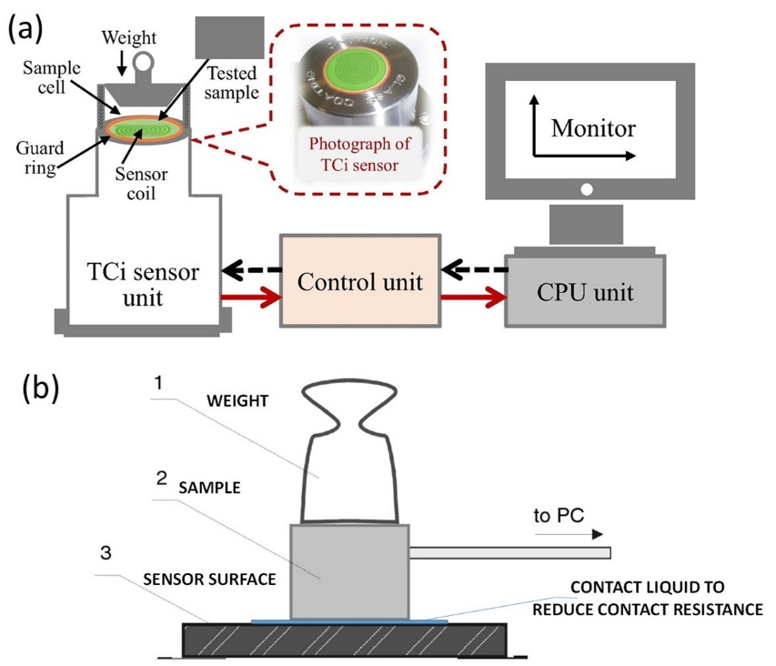

**Figure 1.** (a) Schematic of the experimental set-up for thermal conductivity measurements and photograph of the sensor. (b) Schematic of the sample positioning and contact with the sensor. A ½ kg weight is placed on the sample to minimize contact resistance.

It must be noted that polymeric coating thermal conductivity needs to be measured on a substrate that should have a very high thermal conductivity so that it does not have a thermal resistance. In this case, Al has about 200 W/mK thermal conductivity and unless the coating thermal conductivity is much higher than this value, the measured thermal conductivity will be that of the coating. To test this, pure unfilled PVDF coatings on the same substrate were tested and the measured thermal conductivity was 0.3 W/mK, which appears to be similar to pure PVDF coatings that used other ceramic fillers [36]. A minimum of 20 measurements were performed for each nanocomposite sample tested.

**3. Results and Discussions**

All thermally conductive coating inks when spray coated on the cleaned commercial aluminum foils without any surface roughness modification resulted in significant de-wetting and the cured coatings were not continuous as shown in Figure S1. In particular, we noted formation of different and irregular patterns of ink droplets or blobs depending on the surface finish and roughness of each aluminum substrate. As was mentioned earlier, thin aluminum foils (30 µm) had two dissimilar surfaces, polished in Fig. S1a (Al-F) and mat in Fig. S1b (Al-B) while the thick aluminum plate (Al-T, 1.2 mm) had both unpolished surfaces of similar nature as shown in Figure S1c. All three surfaces were defined by their distinct roughness values as seen in Figure S1 with the polished machined surface of the aluminum foil being the less rough with an average roughness of 0.08 m. It is known that, in fact, dewetting phenomenon is influenced by several factors including surface and morphological properties of the substrate [37]. On the other hand, dimethylacetamide (DMAC) is very high boiling point solvent (165oC) and hence upon spray coating, DMAC droplets would not evaporate during their flight and land on the substrate as liquid droplets. It appears that instead of spreading into a continuous film on all the as-received Al surfaces, the coating contact line recedes back into drop-like shapes. Although the detailed mechanism of this effect is beyond the scope of this work, the de-wetting effect seen herein could be explained by the elastic-like description of contact lines once their motion is perturbed in a particular way by the substrate [38-41]. This perturbation is described by a capillary energy that is proportional to a surface roughness scale that can retract the contact line [41]. Hence, in order to eliminate such perturbations on the contact line of the spreading drops, we have used standard abrasive techniques to modify the as-received surfaces with the following different protocols. We used SiC abrasive papers with different grain sizes, abrasion time and motion such as linear and circular for each particular surface and selected the best abrasion protocol once no dewetting was observed after spray deposition. In the case of Al-F, the optimized abrasion method was the use of fine grade P1200 abrasive paper with an average SiC particle diameter of 15.3 m maintaining linear abrasion for 60 seconds. In the case, of Al-B surface, we used P800 (20 m) and P1200 papers for 60 seconds each with linear motion and finally, for Al-T surface we used P120 SiC paper with an average particle size of 115 m with again 60 seconds of linear abrasion motion. Note than for the thin Al foil surfaces Al-F and Al-B, abrasion with coarse grade SiC papers (P600 and lower) were avoided since they tore into these foils and destroyed them. Abraded surfaces were labeled as Al-FA, Al-BA and Al-TA in order to distinguish them from the as-received surfaces. The measured surface roughness parameters of all the surfaces studied before and after abrasion are shown in Table 1. Upon abrasion, no dewetting was observed on these surfaces as long as their surface roughness parameters remained within the values indicated in Table 1. Table 2 summarizes the observations on the skewness and kurtosis changes as the surfaces were abraded. On the foil surface, the elimination of dewetting was due to the transformation the balanced surface asperities into sharper microscale valleys. In the case of thick aluminum plate, abrasion did not change the sign of skewness and kurtosis values but upon abrasion skewness moved toward zero while kurtosis moved toward 3, both indicating transformation from a sharp valleyed surface to valleys with softer dips. In all cases however, a surface roughness that is dominant in valleys appear to be a favorable texture to eliminate de-wetting of the sprayed polymer-graphene inks used in this work.

**Table 1**. Measured surface roughness parameters before and after abrasion of aluminum surfaces. Al-FA, Al-BA and Al-TA stand for measurements after abrasion.

|  |  |  |  |  |
| --- | --- | --- | --- | --- |
| Substrate | $S_{a}$ ($µm$) | $$S_{q}$$ | $$S_{sk}$$ | $$S_{ku}$$ |
| Al-F | 0.08±0.02 | 0.10±0.02 | 0.31±0.08 | 2.85±0.88 |
| Al-FA | 0.34±0.10 | 0.44±0.14 | -0.54±0.12 | 2.97±0.38 |
| Al-B | 0.14±0.01 | 0.18±0.01 | 0.05±0.01 | 3.03±0.11 |
| Al-BA | 0.21±0.01 | 0.28±0.02 | -0.72±0.18 | 3.93±0.83 |
| Al-T | 0.31±0.10 | 0.41±0.12 | -0.99±0.16 | 3.70±0.86 |
| Al-TA | 0.81±0.01 | 1.03±0.01 | -0.35±0.09 | 3.35±0.18 |

**Table 2**. Interpretation of measured surface roughness parameters before and after abrasion.

|  |  |  |
| --- | --- | --- |
| Substrate | Roughness Indicator | State of Surface |
| Al-F | Ssk>0, Sku<3 | Smooth wavy peaks and asperities. |
| Al-FA | Ssk<0, Sku~3 | Deep valleys with normal distribution. |
| Al-B | Ssk~0, Sku~3 | Balance of peaks and valleys with normal distribution. |
| Al-BA | Ssk<0, Sku>3 | Valleys with sharp dips. |
| Al-T | Ssk<0, Sku>3 | Valleys with sharp dips |
| Al-TA | Ssk<0, Sku>3 | Valleys with dips. |

Typical morphological features of these surfaces are shown in Figs. S2a-c, in addition to photographs of uniform polymer-GnP composite coatings free from de-wetting discontinuities (Figs. S2d and S2e). Once the de-wetting problem was addressed, we investigated the coating morphology and structure including the effect of thermal hydraulic press (hot press) on the coating morphology. Note that dry coatings (as-sprayed coatings) that were not hot-pressed were only annealed at 150oC for 10 minutes to ensure residual solvents evaporated. The SEM images of a sample nanocomposite film containing 60 wt.% GnPs, before and after 10 minutes of hot press at 150°C, are shown in Fig. 2. Before hot pressing, the morphology of the coatings is such that randomly positioned graphitic platelets are visible that are held together by the polymer matrix. Upon hot pressing, as expected, the coatings were compacted and the surface morphology resembles that of an amorphous polymer coating. The cross-section SEM images of the nanocomposite films clearly demonstrate the effect of hot pressing on the coating compactness. In this particular case for instance, as-sprayed coating thickness decreases by about 85% upon hot pressing from about 26 $µm$ to 4 $µm$. Similar results were obtained for all other GnPs concentrations.

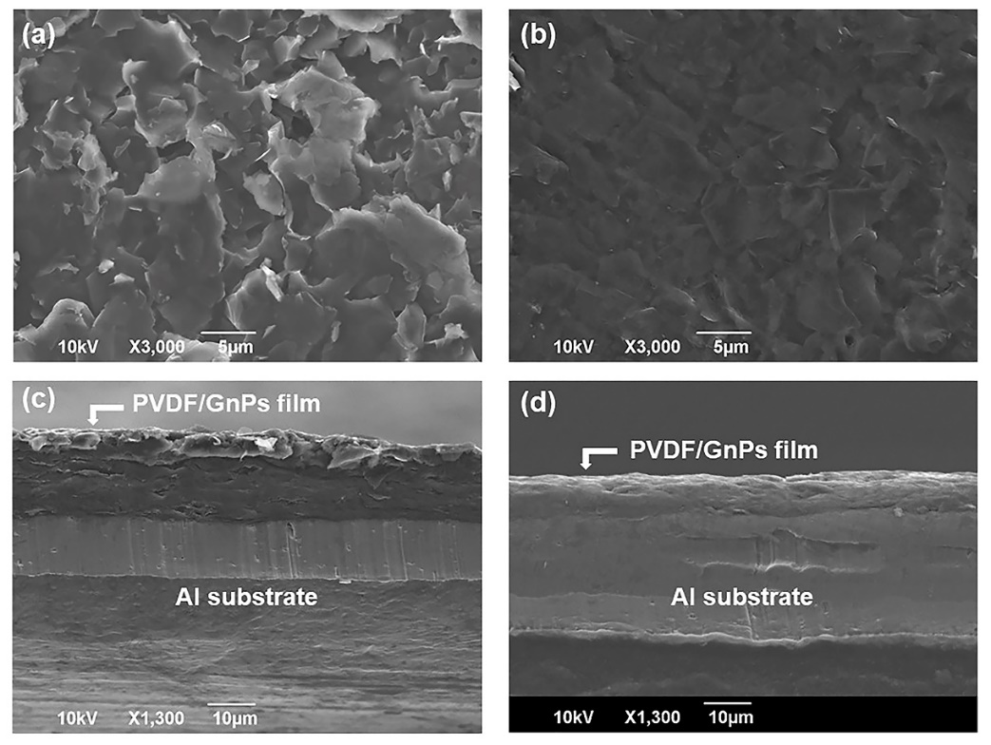

**Figure 2.** Morphological SEM images of PVDF/60 wt.% of GnPs nanocomposite coatings before (a) and after (b) hot pressing. Cross section SEM images of PVDF/60 wt.% of GnPs nanocomposite coatings before (c) and after (d) hot pressing (annealing) at 150°C respectively. The nanocomposite coating thickness in (c) is about 30 microns whereas in (d) it was compressed to about 5 microns.

Figure 3 shows the EDX spectra of the cross sections of the nanocomposite films shown in Fig. 2. Both coatings feature four distinct peaks at 0.277 keV, 0.530 keV, 0.688 keV and at 1.509 keV representing carbon, oxygen, fluorine and aluminum (substrate), respectively. Upon hot pressing similar elemental constitution is preserved but peak intensities are somewhat weaker. This does not mean that there is loss of material from the coating and demonstrates that after hot pressing coating density gets higher and it is compacted. During the EDX measurements, X-rays are generated by any atom in the sample that is sufficiently excited by the incoming beam. These X-rays are emitted in all directions (isotropically), and some may not escape the sample to be detected. The likelihood of an X-ray escaping the specimen and being detected afterwards depends on the energy of the X-ray and the composition, amount, and density of material it has to pass through to reach the detector. In this case, it is also likely that fewer excited rays would arrive at the microscope detector after hot pressing and densifying the coating since the incident excitation beam energy was kept constant.



**Figure 3.** EDX spectra of nanocomposite coatings containing 60 wt.% GnPs on aluminum substrates before (a) and after (b) thermal annealing. Insets in (a) and (b) show EDX images of the corresponding samples before and after thermal annealing, respectively.

Next, the effect of GnP concentration on the coating roughness before and after hot press treatment was studied using the 3D profilometer. As shown in Figure 4, before hot pressing, coating average roughness increases as the GnP concentration increases due to more random formation of GnP flakes on the coating surface. For instance, the nanocomposite coating with 10 wt.% GnP concentration has an average roughness of about 0.6 while the coating with 60 wt.% GnP concentration features an average roughness of about 1.4, more than double. However, when hot pressed, surface roughness of all coatings decline to about 0.25 as seen in Figures 4b and 4c. In Figs. 4b and 4c, the surface morphology of the nanocomposite coating with 40 wt.% GnP concentration is exemplified. Furthermore, Table 3 presents measured roughness, skewness and kurtosis parameters of all the coatings made with various GnP concentrations before and after hot pressing.



**Figure 4.** (a)Arithmetic mean surface roughness $S_{a}$ values obtained for nanocomposite coatings as a function of GnP concentration before and after hot pressing.3D Optical profilometer topography: 3D surface images of PVDF/40 wt.% of GnPs coating before (b) and after (c) hot pressing, respectively.

**Table 3.** Skewness $S_{sk}$ and kurtosis $S_{ku}$ values for nanocomposite coatings before (Pre TA) and after hot pressing (Post TA).

|  |  |  |  |  |
| --- | --- | --- | --- | --- |
| GnP wt.% | $S_{sk}$ Pre TA | $S_{sk}$ Post TA | $S_{ku}$ Pre TA | $S_{ku}$ Post TA |
| 10 | 0.34±0.03 | 0.38±0.04 | 3.03±0.09 | 2.93±0.17 |
| 20 | 0.31±0.08 | 0.08±0.03 | 3.76±0.76 | 3.11±0.35 |
| 30 | 0.32±0.06 | 0.07±0.02 | 3.26±0.66 | 3.01±0.38 |
| 40 | 0.16±0.08 | 0.07±0.04 | 2.95±0.23 | 2.91±0.25 |
| 50 | 0.73±0.19 | 0.16±0.05 | 3.96±0.56 | 3.21±0.60 |
| 60 | 0.47±0.01 | 0.46±0.12 | 3.07±0.21 | 3.23±0.57 |

It appears that skewness is always positive for all the samples regardless of hot pressing. This indicates surface roughness is composed of peaks and asperities as major features. However, upon hot pressing, in general, the skewness is decreased accept for low (10%) and high GnP concentration (60%) cases, indicating a clear smoothing out effect. In the case of Kurtosis, however, before and after hot pressing only small changes occur in kurtosis and most of which remained within the measurement uncertainty. It may be argued that all kurtosis values are close to 3 indicating that the surface heights are normally distributed (i.e. bell curve) rather than sharp dips or peaks and hot pressing do not significantly affect this morphology. The observation that no significant changes occur in Kurtosis before and after hot pressing indirectly shows that elimination of the dewetting problem allows formation of homogeneous coatings.

*3.4 Surface wetting of the coatings*

Coatings applied on the thick Al plates were used to investigate wetting properties (see Fig. 5a). Al foils were also applicable for these tests however thick plates are rigid and do not easily bend. Figure 5 shows static water contact angles on the coatings containing different concentrations of GnPs before and after hot pressing treatment. Pure PVDF coating contact angle was measured to be 95o after hot pressing. Static water contact angle increased from 93o to about 125o when the GnPs concentration was increased from 10 wt.% to 60 wt.%, as shown in Fig. 5b. Upon hot pressing, however, the static water contact angle reduced to 105o at 60 wt.% GnP concentration. It is also evident from Fig. 5b that sensitivity of static water contact angle to GnPs concentration is less when the coatings were hot-pressed. In all cases, no droplet sliding or roll off angles were measured hence the coatings did not have any self-cleaning properties. We also monitored contact angle of droplets on the coatings for up to 3 minutes (spreading kinetics). Figure 5c demonstrates changes in contact angle as a function of time on two sample coatings containing 10 wt.% and 60 wt.% GnPs before and after hot-pressing. Considering the uncertainty in contact angle measurements is about 3o in this case, contact angles remained practically constant and no liquid was absorbed into the coating or spread further. Values reported in Fig. 5b are measurements after 12 seconds of droplet deposition.



**Figure 5.**  (a) Photographs of water contact angle measurement instrument with an exemplary hot pressed nanocomposite coating applied on Al-T substrate. (b) Static water contact angle values on as sprayed (Pre TA) and hot pressed (Post TA) PVDF/GnPs nanocomposite coatings as a function of GnP concentration. (c) Transient water contact angle values on coatings with 10 and 60 wt.% GnP concentrations. Both as sprayed and hot pressed values are reported. As can be seen, coatings do not absorb water droplets and contact angles remain very stable. Values reported in (b) are after 12 seconds as indicated by the dashed line. Pure PVDF hot pressed coating contact angle was 95o and did not change in time.

*3.5 Surface tribology and abrasion resistance*

Tribological properties of the coatings and their wear characteristics have been studied by measuring friction coefficient and inspecting wear tracks on selected coatings, including pure PVDF for comparison purposes. Figure 6a compares friction coefficients of pure PVDF coatings with two hot-pressed coatings having 10 wt.% and 40 wt.% GnPs. Average friction coefficient of pure PVDF was estimated to be 0.16 whereas estimated friction coefficients of coatings with 10 wt.% and 40 wt.% GnPs were about 0.14 and 0.1, respectively. As can be seen, coatings with 40 wt.% GnP loading had lower friction coefficient than pure PVDF. Moreover, as seen in Figure 6b, a much deeper wear scar forms on pure PVDF coatings at the end of ball on disk experiments compared to the 40 wt.% GnP containing coatings (Fig. 6c). These coatings resisted delamination compared to pure PVDF indicating better mechanical properties.

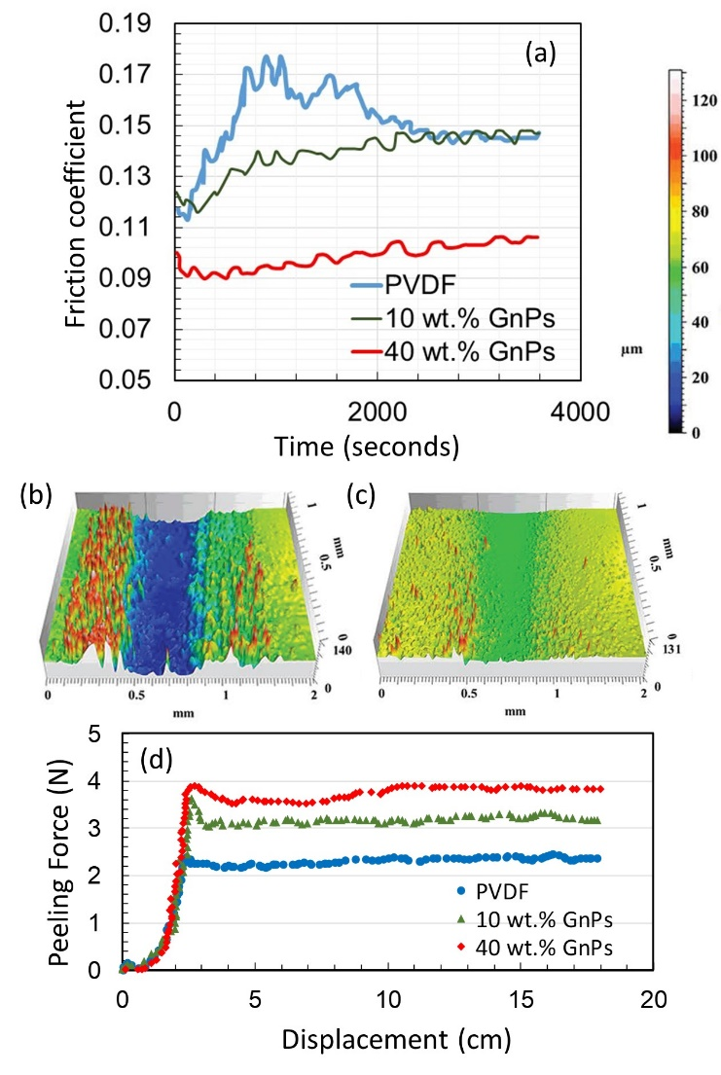

**Figure 6.**  (a) Friction coefficient plot for pure PVDF and two other GnP nanocomposites. (b) Wear track on pure PVDF coating and (c) wear track on 40 wt.% GnPs PVDF hot-pressed composite coating. (d) Peel force-displacement plot for pure PVDF and coatings with 10 wt.% GnPs and 40 wt.% GnPs.

Moreover, Figure 6d demonstrates peel tests applied on the same coatings. Pure hot-pressed PVDF coatings demonstrate about 0.4 N/cm peel adhesion resistance whereas PVDF coatings with GnPs demonstrate 0.6 and 0.8 N/cm peel resistance for 10 wt.% GnPs and 40 wt.% GnPs loadings, respectively. The peel resistance values are relatively better compared to other PVDF-carbon based coating systems that are developed for electrode applications. The acceptable levels are around 0.3 N/cm for composite electrodes for flexible batteries [42].

*3.4 Thermal conductivity of the coatings*

As mentioned in the experimental section, the thermal conductivity of the coatings was measured by using C-Therm TCi Thermal Conductivity Analyzer. It employs the modified transient plane source (MTPS) technique in characterizing the thermal conductivity and effusivity of materials [43,44]. It has a one-sided, interfacial heat reflectance sensor that applies a momentary constant heat source to the sample. Typically, the measurement pulse is between 1 to 3 seconds. Thermal conductivity and effusivity are measured directly, providing a detailed overview of the heat transfer properties of the sample material. It has been shown that the conventional transient plane source method has certain accuracy issues related to the measurement of bulk thermal conductivity of thin films and coatings, because of the existence of thermal contact resistance [45]. In order to minimize this issue, for thermal measurements thicker Al plate was used (approx. 1.5 mm, see Fig. 1b) and thicker coatings were applied on the Al-T substrates (10 layers). As control, pure polymeric coatings were also made and thermal conductivity of the PVDF coatings was compared with the published works. We measured about 0.3 W/mK for 50 m thick PVDF coatings containing no GnPs. This value is comparable to other reports on PVDF coatings [46]. As mentioned earlier, in the hot-pressed coating samples, all GnPs inside the coating are compacted and form a graphite like structure (see SEM cross section images in Figs. 4b and 4d). The thermal conductivity of the basal plane of graphite is known to be about 190 W/mK [47]. To be more specific, in plane thermal conductivity of polycrystalline graphite is about 190 W/mK and the cross plane thermal conductivity is about 10 W/mK [48]. Upon hot pressing, the GnPs are mostly aligned along the cross plane direction and as such one could not take advantage of the in plane thermal conductivity of graphite.

Figure 7 shows the measured thermal conductivity of the coatings before and after hot pressing. Indeed, it is seen that the thermal conductivity values of the sprayed coatings are around 10 W/mK.

Hot pressing increases the *k* value to around 13 W/mK at 40 wt.% GnP concentration. This could be due to the fact that the filler GnPs used in this work are made up of about 8-10 graphene layers. Such particles are also known as few layer graphene and have higher thermal conductivity than polycrystalline graphite. In general, their thermal conductivity could be as high as 1000 W/mK when the number of flakes is more than 4, even though much lower than pure graphene [48]. Hot pressing could improve number of contact points between GnPs and this would reflect as increase in *k* from 10 to up to 13 W/mK. It is also important to note that in polymer-nanocarbon composites high filling concentrations do not always guarantee high thermal conductivity due to increased internal thermal contact resistance among the fillers [35]. In Table 4, a list of recently published thermally conducting coatings based on PVDF composites is given. Mostly, graphene, CNTs, SiC and MXene type fillers have been used. The most widely reported thermal conductivity values are around 2 W/mK and below, whereas only very few PVDF based composites (particularly utilizing graphene or GnPs) were shown to demonstrate thermal conductivity values exceeding 10 W/mK including the present work. Finally, Table 5 lists thermal diffusivity () and thermal effusivity () values of all the coatings fabricated as a function GnPs concentration. Thermal diffusivity measures the rate of transfer of heat of a material from the hot end to the cold end. Thermal diffusivity can be viewed as the ratio of the time derivative of temperature to its curvature, quantifying the rate at which temperature concavity is smoothed out. In a sense, thermal diffusivity is the measure of thermal inertia.



**Figure 7.** Thermal conductivity $k$ variation values obtained for all as sprayed (pre TA) and hot pressed (Post TA) coatings as function of GnP concertation.

In a substance with high thermal diffusivity, heat moves rapidly through it because the substance conducts heat quickly relative to its volumetric heat capacity or thermal bulk. Pyrolytic graphite has about 1.22 × 10−3 m2/s, which is half of the coatings produced before hot pressing. Hot pressing slightly increases thermal diffusivity indicating that compact coatings feature slightly faster heat transfer across the coating thickness [54].

**Table 4.** Thermal interface materials based on PVDF with various thermal conductive fillers.

|  |  |  |  |  |
| --- | --- | --- | --- | --- |
| Filler | | Loading | k(W/mK) | Reference |
| Al2O3/graphene | | 40 wt.% | 0.6 | 20 |
| CNT/graphene | | 20 wt.% | 2.5 | 21 |
| Al micro-particles | | 60 wt.% | 1.65 | 22 |
| Zn micro-particles | | 25 vol.% | 1.20 | 23 |
| Graphene | | 20 wt.% | 0.60 | 24 |
| Al/-SiCw | 55 vol.% | | 2.50 | 25 |
| AlN | 60 vol.% | | 11.50 | 26 |
| MXene | 5 wt.% | | 0.36 | 27 |
| Ni@NiO | 30 vol.% | | 1.5 | 28 |
| MWCNT/SiC | 15 vol.% | | 1.8 | 49 |
| Graphene/nanodiamond | 50 wt.% | | 0.70 | 50 |
| Fe/rGO | 2.5 wt.% | | 1.0 | 51 |
| Al/CNT | 1.0 wt.% | | 1.8 | 52 |
| Ba0.6Sr0.4TiO3 | 40 vol.% | | 40 | 53 |
| GnPs | 50 wt.% | | 13 | This work |

A material's thermal effusivity is a measure of its ability to exchange thermal energy with its surroundings. A higher thermal effusivity allows a material to be thermally activated in a more rapid manner and therefore more thermal load can be stored during a dynamic thermal process. As seen in Table 5, hot pressing of the coatings improve thermal effusivity by about 10-15 % and renders the coatings more thermally responsive to temperature changes. High performance carbonaceous foam phase change materials generally have thermal conductivities beyond 20 W/mK with thermal effusivity values ranging from 4,000 to 11,000 Ws1/2/m2K depending on foam structure [55]. These coatings have also featured such thermal performance without the complexity of building 3D structures. Hence, these coatings can be very useful in applications where simultaneous temperature sensing and high thermal energy storage capability are required. They can be also studied and utilized as 2D thermal dissipators [56].

**Table 5.** Measured thermal diffusivity $α$ and calculated effusivity $ε$ values of all as sprayed and hot pressed coatings.

|  |  |  |  |  |
| --- | --- | --- | --- | --- |
| GnP wt.% | 𝛼 (m2/s)×10-3  Pre TA | 𝛼 (m2/s)×103  Post TA | 𝜀 (Ws1/2/m2K)  Pre TA | 𝜀 (Ws1/2/m2K)  Post TA |
| 10 | 2.11 | 2.14 | 5444 | 5555 |
| 20 | 2.15 | 2.20 | 5490 | 5691 |
| 30 | 2.13 | 2.28 | 5459 | 5600 |
| 40 | 2.20 | 2.28 | 5557 | 5971 |
| 50 | 2.12 | 2.36 | 5465 | 6199 |
| 60 | 2.20 | 2.29 | 5716 | 5990 |

**4. Conclusions**

Hydrophobic polymeric nanocomposite coatings with high thermal conductivity were fabricated by using PVDF and GnPs. Thermal conductivity of the nanocomposite coatings containing 40 wt.% GnPs was measured to be 12 W/mK. Coatings were spray deposited on commercial aluminum foils and afterwards hot pressed to compact the GnPs dispersed in the coatings. Dewetting during spray deposition was a severe problem. It was eliminated by mechanical abrasion such that substrate surface skewness (*Ssk*) and kurtosis (*Sku*) values were modified to attain substrate roughness profiles rich in microscale valleys. Coating hydrophobicity declined upon hot pressing but static water contact angles did not go below 110o. Calculated thermal effusivity, **, of the coatings containing 40 wt. % GnPs was close to 6000 Ws1/2/m2K indicating potential temperature sensing capability. Moreover, the high thermal effusivity of these coatings can open up new application fields such as coatings applied to advanced materials for resonant ambient thermal energy harvesting [57].

**Acknowledgements**

This work has received funding from the European Union's Horizon 2020 research and innovation program under grant number No 801229. We thank Dr. A. Shayganpour (IIT) and Dr. M. T. Masood (University of Bolton, UK) for assistance with thermal and tribology measurements.

**References**

[1] D. Kumar, L. Li, Z. Chen, Mechanically robust polyvinylidene fluoride (PVDF) based superhydrophobic coatings for self-cleaning applications, Progress in Organic Coatings, 101 (2016) 385-390.

[2] B. Stadlober, M. Zirkl, M. Irimia-Vladu, Route towards sustainable smart sensors: ferroelectric polyvinylidene fluoride-based materials and their integration in flexible electronics, Chemical Society Reviews, 48 (2019) 1787-1825.

[3] C. Peng, S. Xing, Z. Yuan, J. Xiao, C. Wang, J. Zeng, Preparation and anti-icing of superhydrophobic PVDF coating on a wind turbine blade, Applied Surface Science, 259 (2012) 764-768.

[4] B. Lee, W. Woo, H. Park, H. Hahm, J. Wu, M. Kim, Influence of aspect ratio and skin effect on EMI shielding of coating materials fabricated with carbon nanofiber/PVDF, Journal of materials science, 37 (2002) 1839-1843.

[5] H. Wang, Z. Liu, E. Wang, R. Yuan, D. Gao, X. Zhang, Y. Zhu, A robust superhydrophobic PVDF composite coating with wear/corrosion-resistance properties, Applied Surface Science, 332 (2015) 518-524.

[6] J. Luo, C.C. Fang, N.L. Wu, High polarity poly (vinylidene difluoride) thin coating for dendrite‐free and high‐performance lithium metal anodes, Advanced Energy Materials, 8 (2018) 1701482.

[7] V.F. Cardoso, D.M. Correia, C. Ribeiro, M.M. Fernandes, S. Lanceros-Méndez, Fluorinated polymers as smart materials for advanced biomedical applications, Polymers, 10 (2018) 161.

[8] T. Huang, S. Yang, P. He, J. Sun, S. Zhang, D. Li, Y. Meng, J. Zhou, H. Tang, J. Liang, Phase-Separation-Induced PVDF/Graphene Coating on Fabrics toward Flexible Piezoelectric Sensors, ACS applied materials & interfaces, 10 (2018) 30732-30740.

[9] K. Silakaew, P. Thongbai, Suppressed loss tangent and conductivity in high-permittivity Ag-BaTiO3/PVDF nanocomposites by blocking with BaTiO3 nanoparticles, Applied Surface Science, 492 (2019) 683-689.

[10] M.A. Rahman, G.-S. Chung, Synthesis of PVDF-graphene nanocomposites and their properties, Journal of Alloys and Compounds, 581 (2013) 724-730.

[11] C. Zhao, X. Xu, J. Chen, G. Wang, F. Yang, Highly effective antifouling performance of PVDF/graphene oxide composite membrane in membrane bioreactor (MBR) system, Desalination, 340 (2014) 59-66.

[12] M. Abbasipour, R. Khajavi, A.A. Yousefi, M.E. Yazdanshenas, F. Razaghian, The piezoelectric response of electrospun PVDF nanofibers with graphene oxide, graphene, and halloysite nanofillers: a comparative study, Journal of Materials Science: Materials in Electronics, 28 (2017) 15942-15952.

[13] W. Jang, J. Yun, K. Jeon, H. Byun, PVdF/graphene oxide hybrid membranes via electrospinning for water treatment applications, Rsc Advances, 5 (2015) 46711-46717.

[14] X. Wu, B. Zhao, L. Wang, Z. Zhang, H. Zhang, X. Zhao, X. Guo, Hydrophobic PVDF/graphene hybrid membrane for CO2 absorption in membrane contactor, Journal of Membrane Science, 520 (2016) 120-129.

[15] M.M. Abolhasani, K. Shirvanimoghaddam, M. Naebe, PVDF/graphene composite nanofibers with enhanced piezoelectric performance for development of robust nanogenerators, Composites Science and Technology, 138 (2017) 49-56.

[16] M.A. Rahman, B.-C. Lee, D.-T. Phan, G.-S. Chung, Fabrication and characterization of highly efficient flexible energy harvesters using PVDF–graphene nanocomposites, Smart materials and structures, 22 (2013) 085017.

[17] S. Garain, S. Jana, T.K. Sinha, D. Mandal, Design of in situ poled Ce3+-doped electrospun PVDF/graphene composite nanofibers for fabrication of nanopressure sensor and ultrasensitive acoustic nanogenerator, ACS applied materials & interfaces, 8 (2016) 4532-4540.

[18] D.-a. Zha, S. Mei, Z. Wang, H. Li, Z. Shi, Z. Jin, Superhydrophobic polyvinylidene fluoride/graphene porous materials, Carbon, 49 (2011) 5166-5172.

[19] J.S. Lee, K.-Y. Shin, C. Kim, J. Jang, Enhanced frequency response of a highly transparent PVDF–graphene based thin film acoustic actuator, Chemical Communications, 49 (2013) 11047-11049.

[20] R. Qian, J. Yu, C. Wu, X. Zhai, P. Jiang, Alumina-coated graphene sheet hybrids for electrically insulating polymer composites with high thermal conductivity, RSC Advances, 3 (2013) 17373-17379.

[21] Y.-j. Xiao, W.-y. Wang, X.-j. Chen, T. Lin, Y.-t. Zhang, J.-h. Yang, Y. Wang, Z.-w. Zhou, Hybrid network structure and thermal conductive properties in poly (vinylidene fluoride) composites based on carbon nanotubes and graphene nanoplatelets, Composites Part A: Applied Science and Manufacturing, 90 (2016) 614-625.

[22] Zhou, W., Zuo, J., & Ren, W. (2012). Thermal conductivity and dielectric properties of Al/PVDF composites. Composites Part A: Applied Science and Manufacturing, 43(4), 658-664.

23. Zhou, W., Wang, Z., Dong, L., Sui, X., & Chen, Q. (2015). Dielectric properties and thermal conductivity of PVDF reinforced with three types of Zn particles. Composites Part A: Applied Science and Manufacturing, 79, 183-191.

24. Guo, H., Li, X., Li, B., Wang, J., & Wang, S. (2017). Thermal conductivity of graphene/poly (vinylidene fluoride) nanocomposite membrane. Materials & Design, 114, 355-363.

25. Zhou, W., Chen, Q., Sui, X., Dong, L., & Wang, Z. (2015). Enhanced thermal conductivity and dielectric properties of Al/β-SiCw/PVDF composites. Composites Part A: Applied Science and Manufacturing, 71, 184-191.

26. Xu, Y., Chung, D. D. L., & Mroz, C. (2001). Thermally conducting aluminum nitride polymer-matrix composites. Composites Part A: Applied science and manufacturing, 32(12), 1749-1757.

27. Cao, Y., Deng, Q., Liu, Z., Shen, D., Wang, T., Huang, Q., ... & Yu, J. (2017). Enhanced thermal properties of poly (vinylidene fluoride) composites with ultrathin nanosheets of MXene. RSC advances, 7(33), 20494-20501.

28. Zhou, W., Gong, Y., Tu, L., Xu, L., Zhao, W., Cai, J., ... & Zhou, A. (2017). Dielectric properties and thermal conductivity of core-shell structured Ni@ NiO/poly (vinylidene fluoride) composites. Journal of Alloys and Compounds, 693, 1-8.

[29] G. He, X. Tian, Y. Dai, X. Li, C. Lin, Z. Yang, S. Liu, Bioinspired interfacial engineering of polymer based energetic composites towards superior thermal conductivity via reducing thermal resistance, Applied Surface Science, 493 (2019) 679-690.

[30] M. El Achaby, F. Arrakhiz, S. Vaudreuil, E. Essassi, A. Qaiss, Piezoelectric β-polymorph formation and properties enhancement in graphene oxide–PVDF nanocomposite films, Applied Surface Science, 258 (2012) 7668-7677.

[31] D. Hernández-Rivera, G. Rodríguez-Roldán, R. Mora-Martínez, E. Suaste-Gómez, A capacitive humidity sensor based on an electrospun PVDF/graphene membrane, Sensors, 17 (2017) 1009.

[32] Z. Wang, H. Yu, J. Xia, F. Zhang, F. Li, Y. Xia, Y. Li, Novel GO-blended PVDF ultrafiltration membranes, Desalination, 299 (2012) 50-54.

[33] W. Zhou, D. Yu, Q. An, A novel polymeric coating with high thermal conductivity, Polymer-Plastics Technology and Engineering, 48 (2009) 1230-1238.

[34] L. Jing, J. LIANG, L. Yeming, High-thermal conductive coating used on metal heat exchanger, Chinese Journal of Chemical Engineering, 22 (2014) 596-601.

[35] A. Shayganpour, S. Naderizadeh, S. Grasselli, A. Malchiodi, I.S. Bayer, Stacked-Cup Carbon Nanotube Flexible Paper Based on Soy Lecithin and Natural Rubber, Nanomaterials, 9 (2019) 824.

[36] Y. Li, X. Huang, Z. Hu, P. Jiang, S. Li, T. Tanaka, Large dielectric constant and high thermal conductivity in poly (vinylidene fluoride)/barium titanate/silicon carbide three-phase nanocomposites, ACS applied materials & interfaces, 3 (2011) 4396-4403.

[37] C.V. Thompson, Solid-state dewetting of thin films, Annual Review of Materials Research, 42 (2012) 399-434.

[38] R. Golestanian, E. Raphaël, Dissipation in dynamics of a moving contact line, Physical Review E, 64 (2001) 031601.

[39] R. Golestanian, E. Raphaël, Relaxation of a moving contact line and the Landau-Levich effect, EPL (Europhysics Letters), 55 (2001) 228.

[40] R. Golestanian, E. Raphaël, Roughening transition in a moving contact line, Physical Review E, 67 (2003) 031603.

[41] G. Delon, M. Fermigier, J.H. Snoeijer, B. Andreotti, Relaxation of a dewetting contact line. Part 2. Experiments, Journal of Fluid Mechanics, 604 (2008) 55-75.

[42] Gaikwad, A. M., & Arias, A. C. (2017). Understanding the effects of electrode formulation on the mechanical strength of composite electrodes for flexible batteries. ACS applied materials & interfaces, 9(7), 6390-6400.

[43] M. Anis-ur-Rehman, A. Maqsood, A modified transient method for an easy and fast determination of thermal conductivities of conductors and insulators, Journal of Physics D: Applied Physics, 35 (2002) 2040.

[44] T. Log, S. Gustafsson, Transient plane source (TPS) technique for measuring thermal transport properties of building materials, Fire and materials, 19 (1995) 43-49.

[45] M. Ahadi, M. Andisheh-Tadbir, M. Tam, M. Bahrami, An improved transient plane source method for measuring thermal conductivity of thin films: Deconvoluting thermal contact resistance, International Journal of Heat and Mass Transfer, 96 (2016) 371-380.

[46] Bama, G. K., Devi, P. I., & Ramachandran, K. (2009). Structural and thermal properties of PVDF/PVA blends. Journal of materials science, 44(5), 1302-1307.

[47] P. Klemens, D. Pedraza, Thermal conductivity of graphite in the basal plane, Carbon, 32 (1994) 735-741.

[48] A.A. Balandin, Thermal properties of graphene and nanostructured carbon materials, Nature materials, 10 (2011) 569-581.

[49] Cao, J. P., Zhao, J., Zhao, X., You, F., Yu, H., Hu, G. H., & Dang, Z. M. (2013). High thermal conductivity and high electrical resistivity of poly (vinylidene fluoride)/polystyrene blends by controlling the localization of hybrid fillers. Composites Science and Technology, 89, 142-148.

[50] Yu, J., Qian, R., & Jiang, P. (2013). Enhanced thermal conductivity for PVDF composites with a hybrid functionalized graphene sheet-nanodiamond filler. Fibers and Polymers, 14(8), 1317-1323.

[51] Karan, S. K., Das, A. K., Bera, R., Paria, S., Maitra, A., Shrivastava, N. K., & Khatua, B. B. (2016). Effect of γ-PVDF on enhanced thermal conductivity and dielectric property of Fe-rGO incorporated PVDF based flexible nanocomposite film for efficient thermal management and energy storage applications. RSC advances, 6(44), 37773-37783.

[52] Wang, Z., Zhou, W., Sui, X., & Dong, L. (2015). Enhanced dielectric properties and thermal conductivity of Al/CNTs/PVDF ternary composites. Journal of Reinforced Plastics and Composites, 34(14), 1126-1135.

[53] Hu, G., Gao, F., Kong, J., Yang, S., Zhang, Q., Liu, Z., ... & Sun, H. (2015). Preparation and dielectric properties of poly (vinylidene fluoride)/Ba0. 6Sr0. 4TiO3 composites. Journal of Alloys and Compounds, 619, 686-692.

[54] B. Venkanna, Fundamentals of heat and mass transfer, PHI Learning Pvt. Ltd., 2010.

[55] H. Lei, C. Fu, Y. Zou, S. Guo, J. Huo, A thermal energy storage composite with sensing function and its thermal conductivity and thermal effusivity enhancement, Journal of Materials Chemistry A, 7 (2019) 6720-6729.

[56] Zahid, M., Masood, M. T., Athanassiou, A., & Bayer, I. S. (2018). Sustainable thermal interface materials from recycled cotton textiles and graphene nanoplatelets. Applied Physics Letters, 113(4), 044103.

[57] Cottrill, A. L., Liu, A. T., Kunai, Y., Koman, V. B., Kaplan, A., Mahajan, S. G., ... & Strano, M. S. (2018). Ultra-high thermal effusivity materials for resonant ambient thermal energy harvesting. Nature Communications, 9(1), 1-11.